|  |  |
| --- | --- |
| **Normal growth pH range** | **Crop** |
| 6.5 – 7.5 | Alfalfa |
| 5.0 – 6.5 | Apples |
| 6.3 – 7.0 | Barley |
| 6.0 – 7.0 | Birsdfoot trefoil |
| 6.0 – 7.5 | Cabbage |
| 5.8 – 7.0 | Clovers |
| 5.8 – 7.0 | Corn |
| 5.5 – 6.5 | Cotton |
| 5.5 – 7.0 | Cucumbers |
| 6.0 – 7.5 | Flaxseed |
| 5.5 – 6.5 | Grain Sorghum |
| 5.8 – 7.0 | Grasses |
| 6.0 – 6.5 | Green beans |
| 5.8 – 7.0 | Oats |
| 5.5 – 6.5 | Onions |
| 5.5 – 6.5 | Peanuts |
| 5.0 – 5.5 | Potatoes |
| 5.5 – 6.5 | Rice |
| 5.0 – 7.0 | Rye |
| 6.5 – 7.5 | Soybeans |
| 6.5 – 7.0 | Sugar Beets |
| 6.3 – 7.0 | Wheat |

*Information compiled from Mosaic Crop Nutrition, Cornell University Cooperative Extension, Iowa State University Extension, Oregon State University, and SFGate.

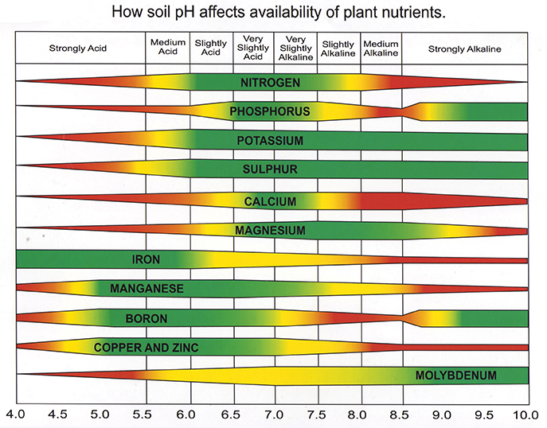

*Chart from Jonathan Green; Quality Lawns.